Textures

📘 Definition
# Source: AI Source: Provided by: [Data Path: Persons Table -> ID Column: 1, Name_En Column: Motasem Essam] -> From: [ChatGPT] on [5/2/2026]
Textures are images or patterns applied to the surface of 3D objects to make them look more realistic and detailed.
Instead of a plain color, textures add real-world surface details like wood grain, skin, metal, or fabric.

🎨 How textures work
# Source: AI Source: Provided by: [Data Path: Persons Table -> ID Column: 1, Name_En Column: Motasem Essam] -> From: [ChatGPT] on [5/2/2026]
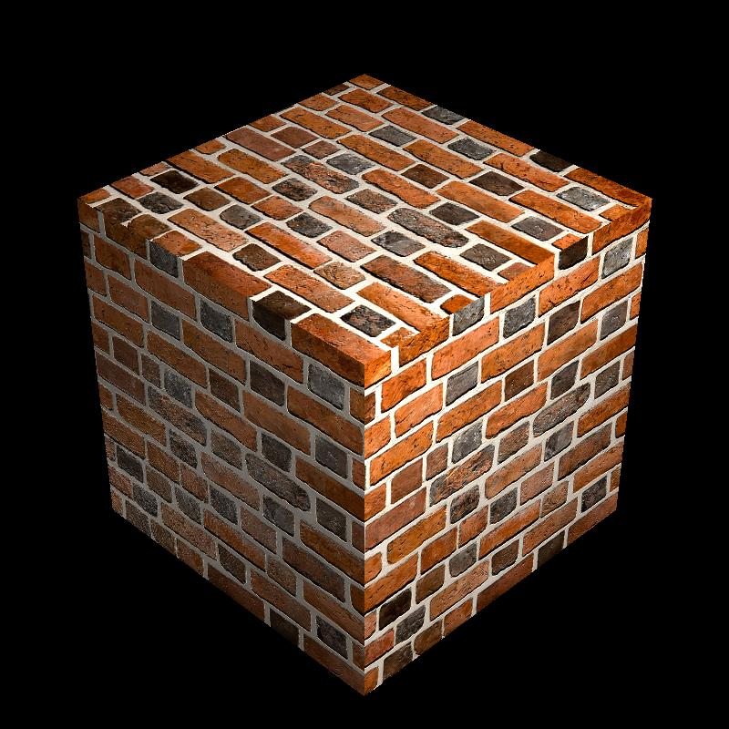
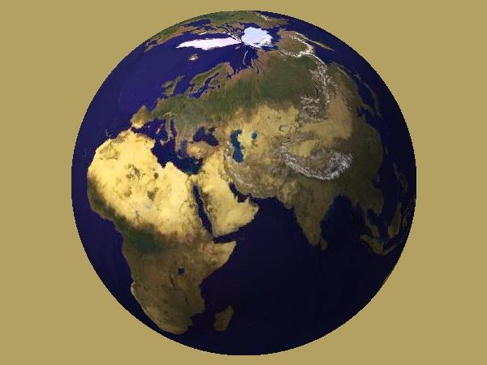
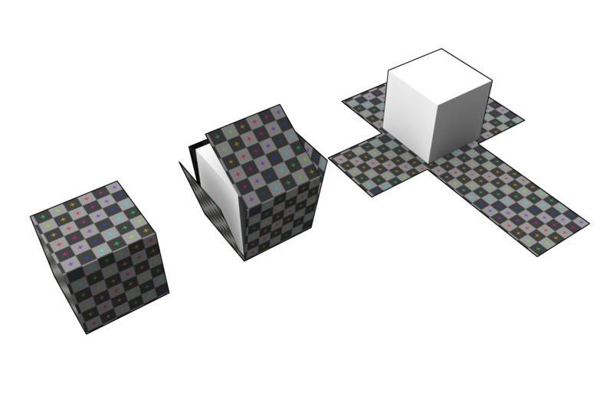
- A flat image (texture map) is created
- It is wrapped onto a 3D model
- The surface then looks detailed and realistic
- This process is called texture mapping

🧠 Simple example
# Source: AI Source: Provided by: [Data Path: Persons Table -> ID Column: 1, Name_En Column: Motasem Essam] -> From: [ChatGPT] on [5/2/2026]
Think of:
- 🧱 A plain cube → looks simple
- 🧱 Same cube with brick texture → looks like a real wall
- ⚽ A sphere with Earth texture → looks like the planet Earth

🎮 Types of textures
# Source: AI Source: Provided by: [Data Path: Persons Table -> ID Column: 1, Name_En Column: Motasem Essam] -> From: [ChatGPT] on [5/2/2026]
- 🎨 Color (Diffuse) texture → basic surface color
- ✨ Specular texture → shiny areas
- 🌫️ Normal/Bump texture → fake bumps and depth
- 🌍 Environment texture → reflections like sky or surroundings

🎮 Where textures are used
# Source: AI Source: Provided by: [Data Path: Persons Table -> ID Column: 1, Name_En Column: Motasem Essam] -> From: [ChatGPT] on [5/2/2026]
- 🎮 Video games (characters, buildings, maps)
- 🎬 Movies and animation (realistic CGI)
- 🧑‍💻 3D modeling and design
- 🏗️ Architecture visualization

⚙️ Key features
# Source: AI Source: Provided by: [Data Path: Persons Table -> ID Column: 1, Name_En Column: Motasem Essam] -> From: [ChatGPT] on [5/2/2026]
- 🖼️ Made from 2D images
- 🧩 Applied to 3D surfaces
- 🎯 Adds realism and detail
- 💻 Saves time compared to modeling fine details

🚀 In short:
# Source: AI Source: Provided by: [Data Path: Persons Table -> ID Column: 1, Name_En Column: Motasem Essam] -> From: [ChatGPT] on [5/2/2026]
Textures = images or patterns applied to 3D objects to make them look realistic and detailed.

